Student Name: __________________
Class and Section __________________
Total Points (20 pts) __________________
Due: September 28, 2016 before the class

Project: Convex Hull

CSCI 2410 Data Structures and Algorithms
Armstrong Atlantic State University

Problem Description:

Given a set of points, a convex hull is a smallest convex polygon that encloses all these points, as shown in Figure 22.8a. A polygon is convex if every line connecting two vertices is inside the polygon. For example, the vertices v0, v1, v2, v3, v4, and v5 in Figure 23.5a form a convex polygon, but not in Figure 22.8b, because the line that connects v3 and v1 is not inside the polygon.
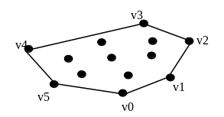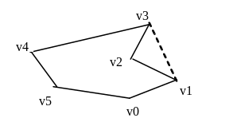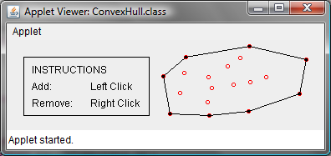
(a) A convex hull (b) A non-convex polygon (c) convex hull animation

Figure 22.8
A convex hull is a smallest convex polygon that contains a set of points.

Convex hull has many applications in game programming, pattern recognition, and image processing. Before we introduce the algorithms, it is helpful to get acquainted with the concept using an interactive tool from www.cs.armstrong.edu/liang/animation/ConvexHull.html, as shown in Figure 22.8c. The tool allows you to add/remove points and displays the convex hull dynamically.

Many algorithms have been developed to find a convex hull. An intuitive approach, called the gift-wrapping algorithm, works as follows:

Step 1: Given a list of points S, let the points in S be labeled s₀, s₁, ..., s_{k}. Select the rightmost lowest point h₀ in S. As shown in Figure 22.9a, h₀ is such a point. Add h₀ to the convex hull H. H is a list initially being empty. Let t₀ be h₀.

Step 2: Let t₁ be s₀.
For every point p in S
if p is on the right side of the direct line from t₀ to t₁ then
let t₁ be p.

(After Step 2, no points lie on the right side of the direct line from t₀ to t₁, as shown in Figure 22.9b.)

Step 3: If t₁ is h₀ (see Figure 22.9d), the points in H form a convex hull for S. Otherwise, add t₁ to H, let t₀ be t₁, and go to Step 2 (see Figure 22.9c).

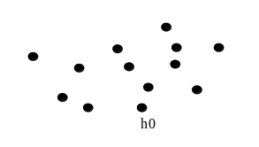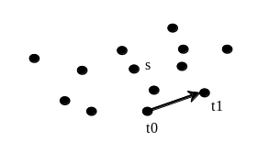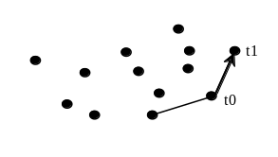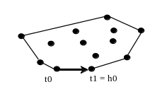
(a) Step 1 (b) Step 2 (c) repeat Step 2 (d) H is found

Figure 22.9
(a) h₀ is the rightmost lowest point in S. (b) Step 2 finds point t₁. (c) A convex hull is expanded repeatedly. (d) A convex hull is found when t₁ becomes h₀.
A console-based program for finding the convex is given to you (mailed separately). Develop a GUI program as shown in Figure 22.5. Name the program Exercise22_13
(Hint: Do it incrementally. Can you add a point? Can you remove a point? Can you find a convex hull? Can you display a convex hull?)

Copy Your Code here:

Screen shots:

What to submit?

1. Complete and submit the hardcopy of this document.

2. Compile and Submit to LiveLab (you must submit the program regardless whether it is complete or incomplete, correct or incorrect)

3. Fill in self-evaluation:

- Can your program add a point?
- Can your program remove a point?
- Can your program display a polygon that connects some points?
- Can your program display a convex hull correctly?

import java.util.ArrayList;
import java.util.Scanner;

public class Exercise22_09 {
public static void main(String[] args) {
Scanner input = new Scanner(System.in);

System.out.print("How many points are in the set? ");
int numberOfPoints = input.nextInt();

double[][] p = new double[numberOfPoints][2];
System.out.print("Enter " + p.length + " points: ");
for (int i = 0; i < p.length; i++)
for (int j = 0; j < p[i].length; j++)
p[i][j] = input.nextDouble();

ArrayList<MyPoint> list = getConvexHull(p);

System.out.print("The convex hull is ");
for (int i = 0; i < list.size(); i++) {
System.out.print("(" + list.get(i).x + ", " + list.get(i).y + ") ");
}
}

static class MyPoint {
double x, y;

MyPoint(double x, double y) {
this.x = x; this.y = y;
}
}

/** Return the points that form a convex hull */
public static ArrayList<MyPoint> getConvexHull(double[][] s) {
// For efficiency, create an array of objects
MyPoint[] myPoints = new MyPoint[s.length];
for (int i = 0; i < myPoints.length; i++)
myPoints[i] = new MyPoint(s[i][0], s[i][1]);

// Step 1
MyPoint h0 = getRightmostLowestPoint(myPoints);
ArrayList<MyPoint> H = new ArrayList<MyPoint>();
H.add(h0);

MyPoint t0 = h0;

// Step 2 and Step 3
while (true) {
MyPoint t1 = myPoints[0];
for (int i = 1; i < myPoints.length; i++) {
double status = whichSide(t0.x, t0.y, t1.x, t1.y, myPoints[i].x, myPoints[i].y);

if (status > 0) // Right side of the line. Please note we are using the Java coordinate system. y increases downward
t1 = myPoints[i];
else if (status == 0) {
if (distance(s[i][0], s[i][1], t0.x, t0.y) > distance(t1.x, t1.y, t0.x, t0.y))
t1 = myPoints[i];
}
}

if (t1.x == h0.x && t1.y == h0.y)
break; // A convex hull is found
else {
H.add(t1);
t0 = t1;
}
}

return H;
}

/** Return the rightmost lowest point in S */
private static MyPoint getRightmostLowestPoint(MyPoint[] p) {
int rightMostIndex = 0;
double rightMostX = p[0].x;
double rightMostY = p[0].y;

for (int i = 1; i < p.length; i++) {
if (rightMostY < p[i].y) {
rightMostY = p[i].y;
rightMostX = p[i].x;
rightMostIndex = i;
}
else if (rightMostY == p[i].y && rightMostX < p[i].x) {
rightMostX = p[i].x;
rightMostIndex = i;
}
}

return p[rightMostIndex];
}

public static double distance(double x1, double y1, double x2, double y2) {
return Math.sqrt((x1 - x2) * (x1 - x2) + (y1 - y2) * (y1 - y2));
}

static double whichSide(double x0, double y0, double x1, double y1, double x2, double y2) {
return (x1 - x0) * (y2 - y0) - (x2 - x0) * (y1 - y0);
}
}

FYR:

*3.32 (Geometry: point position) Given a directed line from point p0(x0, y0) to p1(x1, y1), you can use the following condition to decide whether a point p2(x2, y2) is on the left of the line, on the right, or on the same line (see Figure 3.13):

Figure 3.13
(a) p2 is on the left of the line. (b) p2 is on the right of the line. (c) p2 is on the same line.
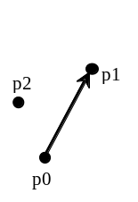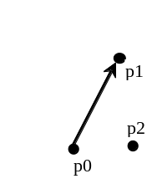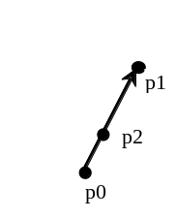

(a) (b) (c)

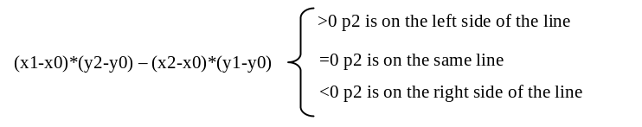
Write a program that prompts the user to enter the three points for p0, p1, and p2 and displays whether p2 is on the left of the line from p0 to p1, to the right, or on the same line. Here are some sample runs:
<output>
Enter three points for p0, p1, and p2: 4.4 2 6.5 9.5 -5 4 <enter icon>
p2 is on the left side of the line
<end output>
<output>
Enter three points for p0, p1, and p2: 1 1 5 5 2 2 <enter icon>
p2 is on the same line
<end output>
<output>
Enter three points for p0, p1, and p2: 3.4 2 6.5 9.5 5 2.5 <enter icon>
p2 is on the right side of the line
<end output>

